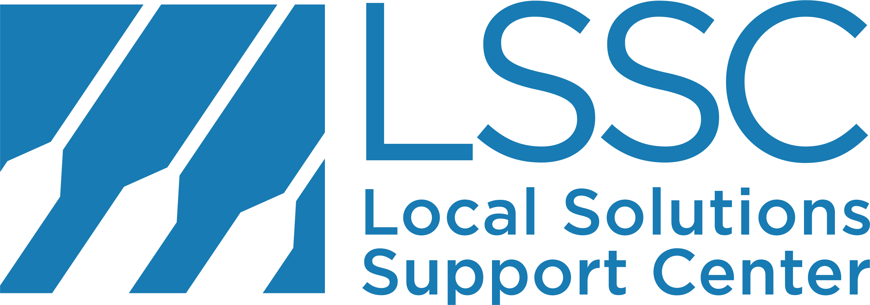

FAQ about Preemption and State Interference

Q: What is preemption?
A: State legislative efforts to stop – or technically “preempt”- local governments from lawmaking across a broad and growing range of local issues. This interference in local decision-making makes it harder for local governments to act on the unique views, values and needs of their communities and undermines our democracy.

Preemption itself is a tool that can be used for good or bad, at present, the increased misuse of state preemption to erode local authority has stopped the advance of innovative and problem-solving policies in many states.

Q: What issue areas does preemption affect?
A: You name it, and preemption can likely touch it. 49 states have some form of preemption laws on their books, affecting issues like:

- Local economies: minimum wages, paid sick time and sick/safe leave, wage theft, local hiring preferences
- Gun violence: local bans on bump stocks, assault weapons, open carry
- Civil Rights: “welcoming” and sanctuary cities policies, limiting local ICE assistance, non-discrimination ordinances, local human rights ordinances
- Elections: local ballot initiatives and referenda
- Environment: fracking bans, plastic bag bans and fees
- Public health: local soda taxes, smoking bans
- New Technology: 5G, broadband, self-driving cars
Preemption can also interfere on hyper-local issues, like parking laws, zoning laws, and short-term rental ordinances.

Q: What happens when local laws are preempted?
A: Your local government’s hands are tied. They cannot move forward in areas that have been preempted. In some cases, laws that have are already in force are nullified.

And for your local mayors and councilmembers, punitive preemption is a growing threat; in some states, local officials can be fined, personally sued, removed from office by the governor, and even jailed up to one year — for just for doing their job – representing their constituents.

Q: Why is preemption happening? Who’s behind this?
A: Preemption is part of a national anti-regulation agenda being pushed by big business, special interests, and their lobbyists. These interest groups lobby state lawmakers to preempt local laws, putting their corporate profits ahead of policies that keep people safe, healthy and prosperous. Some preemption is the result of extreme ideologies (like the so-called “religious freedom acts” in some states that promote anti-LGBT discrimination).

Q: Isn’t this just some arcane government-on-government thing?
A: No. Local government is the only level of government that still works, because it has escaped the political gridlock of state capitols and Congress. Real people’s rights are under assault, mainly from big-money special interests. These state laws mean lower wages and longer hours, they mean going to work sick, they mean worse air and water quality, they mean less jobs for local residents, and they mean more gun violence in our cities that we can’t stop. Voters believe in local control — in national polls, people trust local government over state and the federal governments by a large margin, one -in-six voters believe local government are the best qualified to act on the needs, views and values of local communities, and 70 percent of voters think special interests are behind preemption.

Q. State lawmakers say they need to stop cities and towns from passing local laws so there is uniformity in the law and that businesses don’t have to comply with a patchwork of laws and standards across a state.
A. Businesses deal with different city laws, tax rates and health standards every day. Here’s the truth: corporations know it is easier to defeat policies in 50 state capitols than in the over 19,000 incorporated cities and towns in the United States. If state lawmakers actually believed that “one size fits all,” they would pass statewide standards and protections, rather than blocking them altogether.

Q: What can we do about it?
A: Odds are Local Solutions Support Center is working in your state with advocates, elected officials and organizations to raise awareness, advance legal arguments and policies and organize across issues to make it harder to pass punitive preemption bills Our in-state partners are building diverse coalitions of elected officials and advocates committed to strengthening local democracy. They’re recruiting “home rule” champions willing to speak before media and lawmakers and training local advocates to educate lawmakers, grassroots groups, and the public about preemption’s serious, growing threat to local values. Learn more from Katie Belanger, LSSC Deputy Director.

